Sending an email link to an outside recipient via NetDocument Links from Outlook.

- Start your email in Outlook
You need a draft message open before you can insert a NetDocuments secure link.
Open Outlook → New Email (or reply/forward to an existing email).
- To: enter your external recipient’s email address
- Add a Subject and any message text you want to include
- Click on Attach from the NetDocuments pane in Outlook
- Scroll to the bottom of the “recent list: that appears and browse for your document
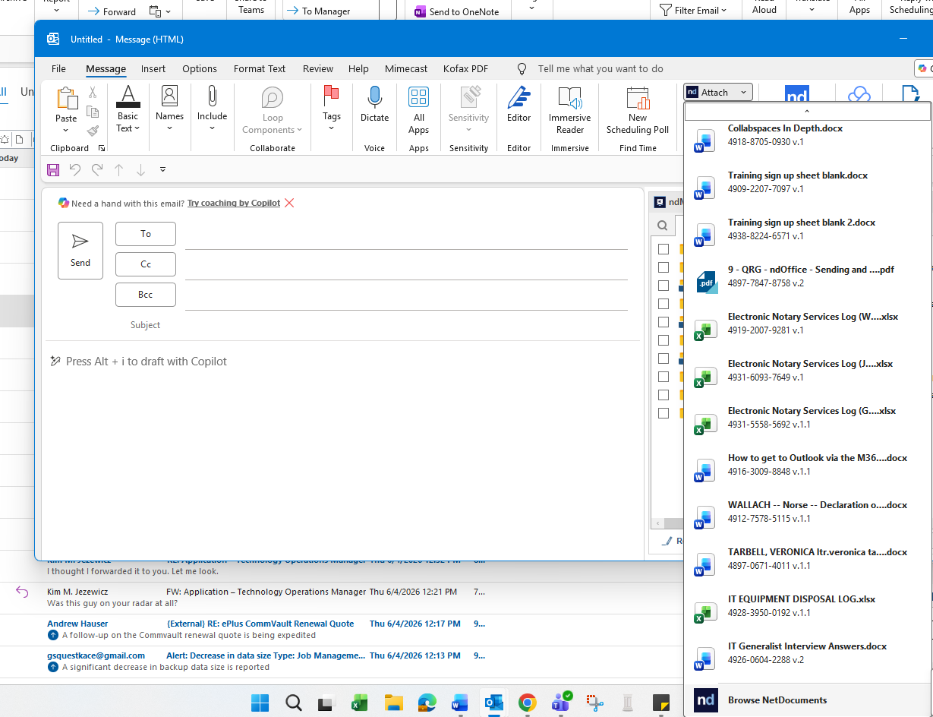
Instead of attaching a file directly, you’ll send a secure NetDocuments link.
- Find the document(s) you wish to share and click on the secured link option at the bottom of the window.
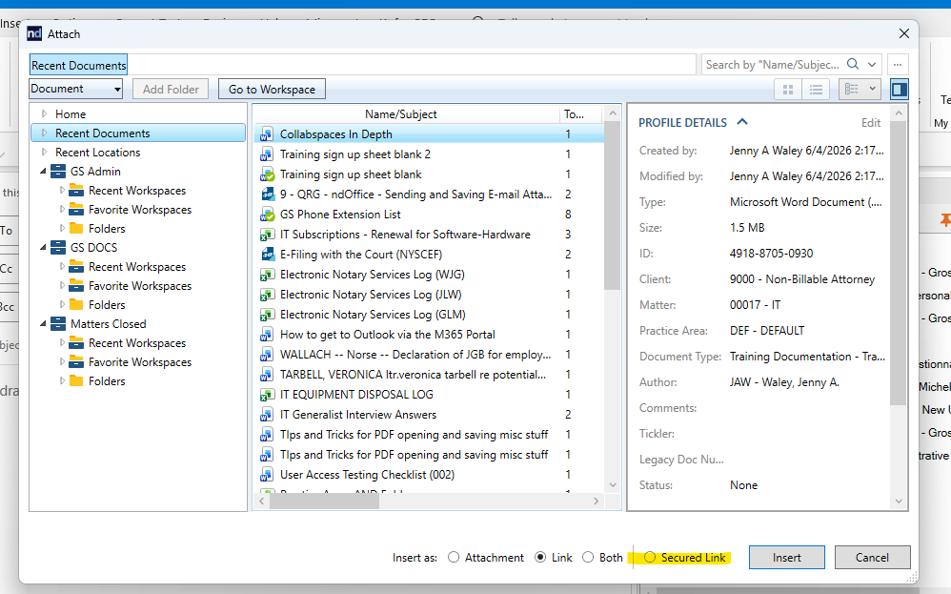
- You will be prompted to enter a password. Type in a password 2 times to ensure it was entered correctly. Also set any other options you wish to set from the “Other Options”
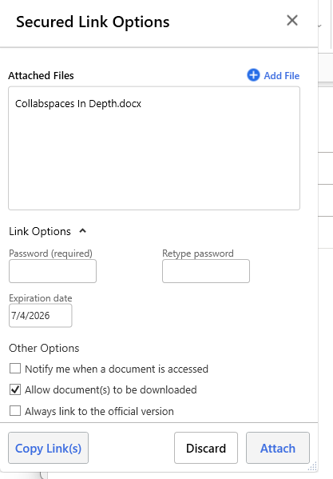
- Allow document(s) to be downloaded: turn on if the recipient may save a copy; off if they should only view
- Password protect: set a strong password if required by firm policy, and plan how you’ll share it (e.g., separate email or phone call)
- Link expiration date: choose an appropriate end date (e.g., 30 days) so access automatically expires
- Always link to the official/current version: enable if you want the recipient to always see the latest official version
- Notify me when a document is accessed: enable if you want email alerts when the link is opened
- Insert the secure link into the email
This step adds the NetDocuments secure link directly into your Outlook message.
- After configuring options, click Attach or Insert in the NetDocuments panel
- Confirm that a hyperlink (or short secure link text) appears in the body of your email
- Optionally, add a short note explaining that the content is being shared via a secure NetDocuments link
- Review and send to the external recipient
Security Check
A quick review helps ensure the secure link works as intended and respects confidentiality.
- Double-check the recipient’s email address and any CC/BCC entries
- Verify that no unintended files are attached—only the secure link
- If you used a password, send it via a separate channel (not in the same email as the link)
- Click Send to deliver the email with the NetDocuments secure link to the external recipient

4911-2060-7922, v. 1

